Beta Defence - Further Development

William Cheung
WilliamCheung2004@gmail.com

Contents
1.0 2
Bug Fixing from previous version 2
Issue 1 : Background Loading 2
Issue 2 : Screen Resizing – Responsive Design 5
Performance Issues: 12
Screen Reformatting – Responsive Design 15
Maximise button – Responsive Design 16

1.0

Bug Fixing from previous version
Previously on the development of Beta Defence I had completed a working basic prototype on what my game should have that including : some enemies that will attack the player, a working turret the player can control and other basic mechanics such as the enemies moving towards the player.
The player currently is able to shoot and being able to take damage as well as being able to gain some currency., this being with an addition of a few bugs of course, so I will attempt to fix them here first before tackling the main game.
First of all though, it has been some time before I had last used and modified the game so there has been some changes to Replit the free online IDE which I had used previously to design and test the game. However as of currently, Replit now had some limitations for free users, therefore, I have now decided to switch to using Visual Studio Code.

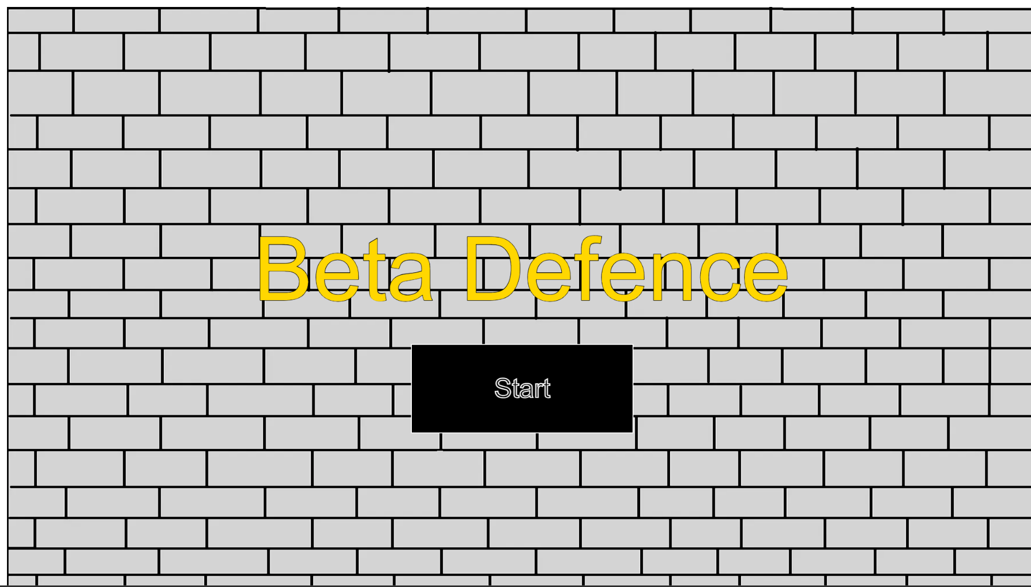

Issue 1 : Background Loading
When loading the game, everything seemed to work fine as before except for one small issue. it immediately caught my attention that for some reason now, there was a small white border around my game and after some testing of the game, this affected the whole game and not just the title screen.
I used a black border for the screenshot here to make this easier to see. I am not sure why this has happened as previously the game had worked flawlessly before so perhaps I would just need to update some of the libraries.

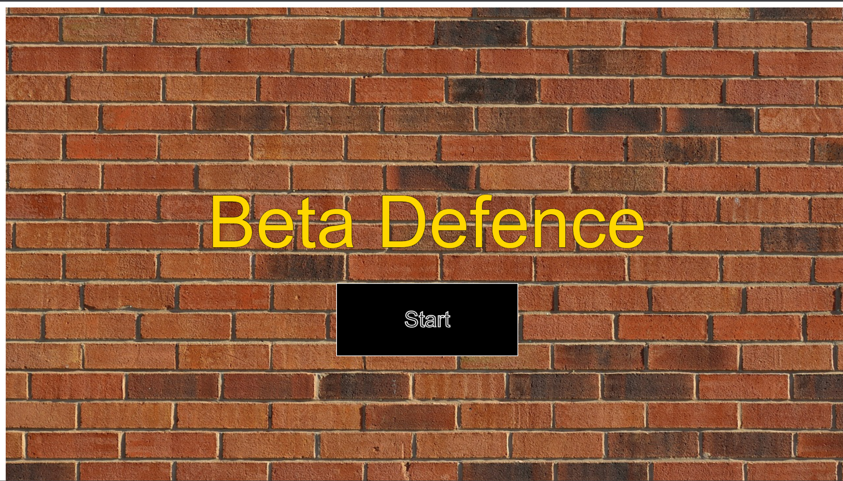
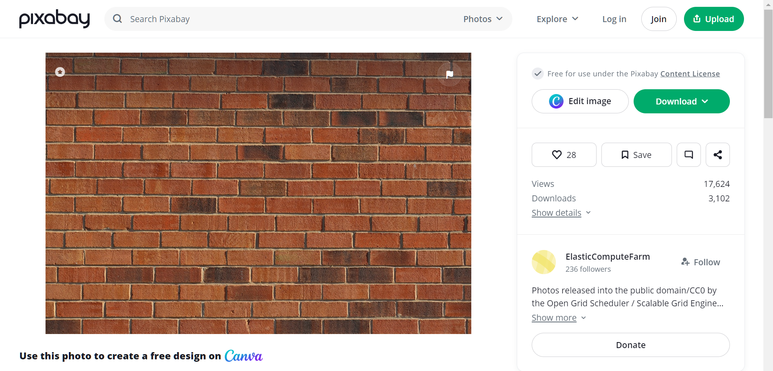
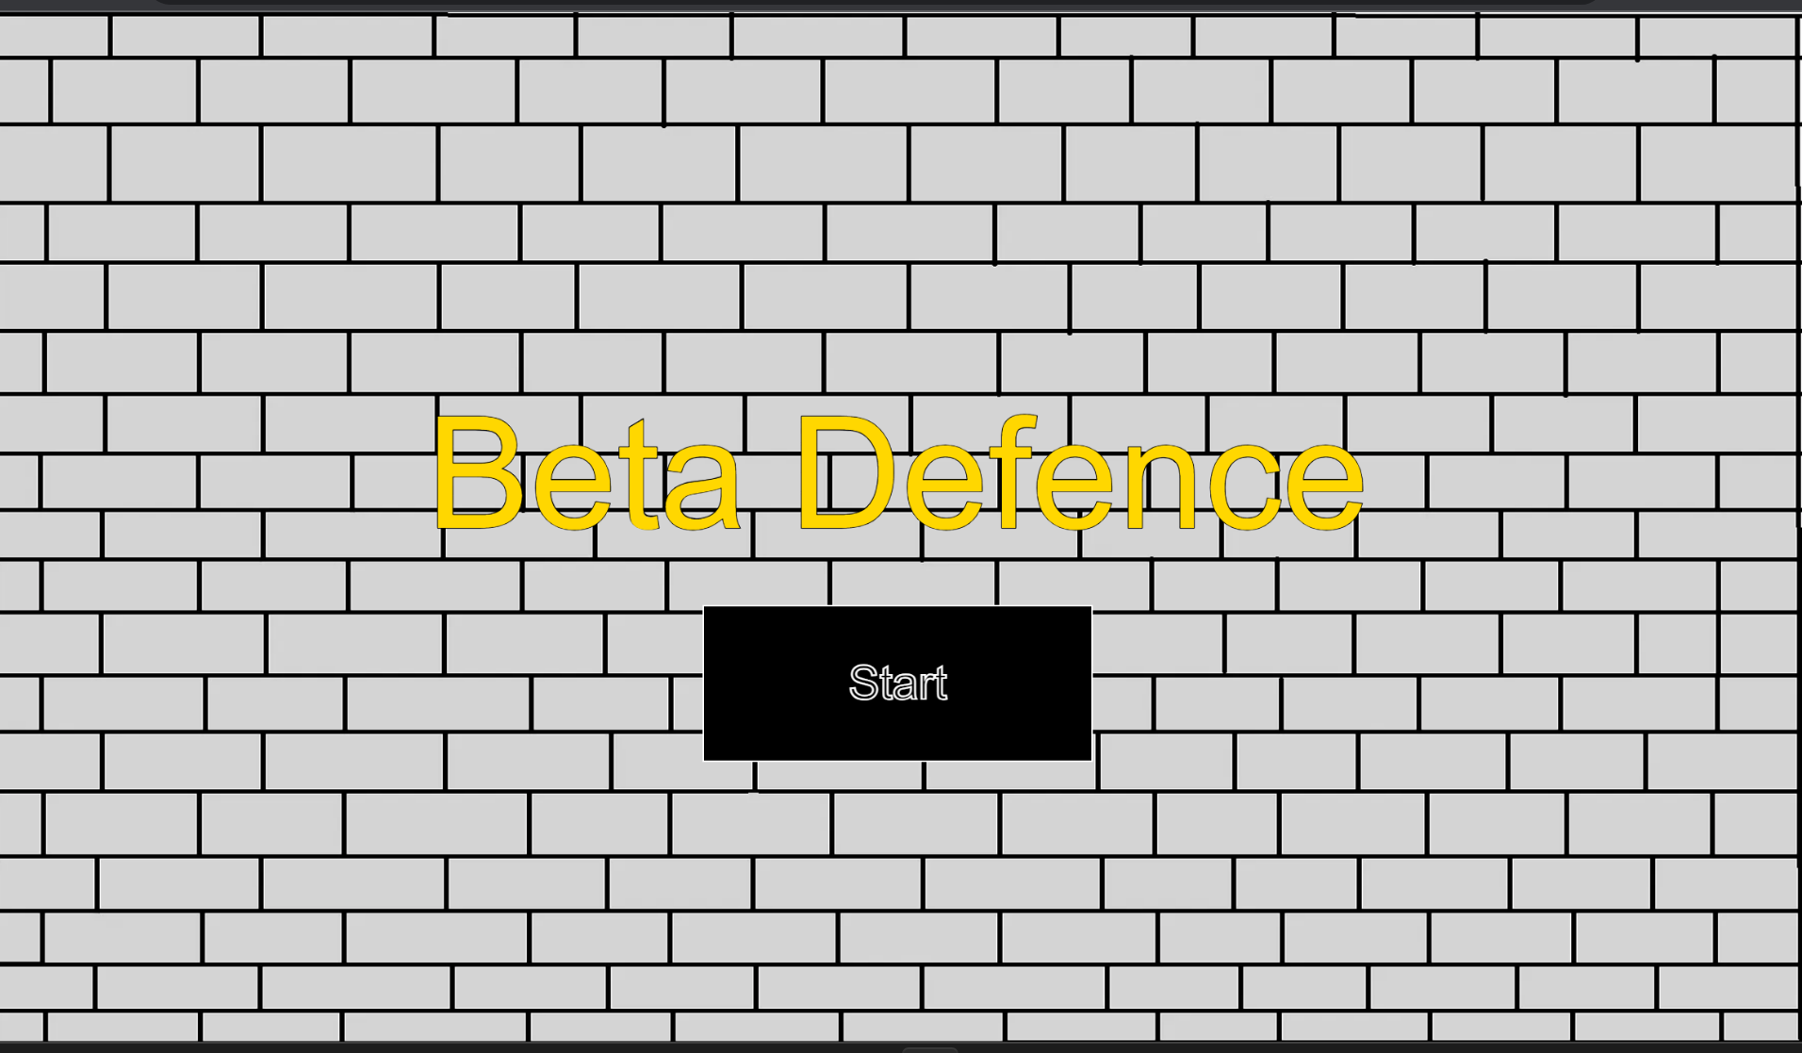
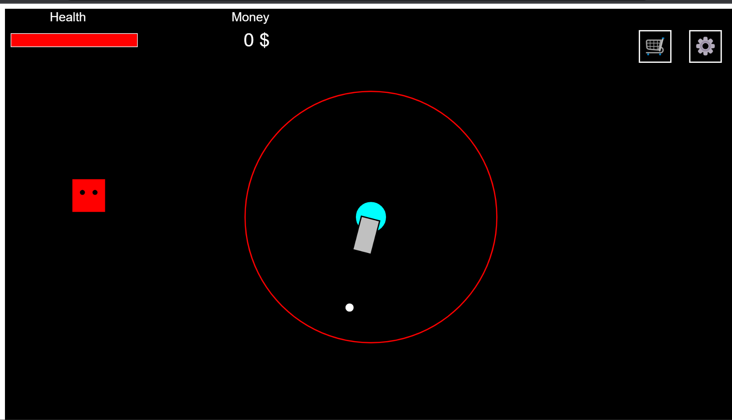
When adding the image to the game, replacing the old background with the test image I downloaded from the website above, I found the same problem had occurred, so the issue here clearly wasn’t the fault of the background image but very evidently something else here was causing the issue.

So, I used a royalty free image from (ElasticComputeFarm, 2023) which provided a full image of a background I can use to test.

Perhaps the issue may be due to the background image itself. Since I created the main background myself within the Window’s paint app, the background may have not scaled properly within the game since I created the image within a small canvas, thus may of causing this error, so trying a new properly rendered image may work.gy
I replaced the old p5 library with the current newest one, unfortunately , this did not solve the current problem though, updating the library may be useful for later use for newer functions and bug fixes.
src="https://cdnjs.cloudflare.com/ajax/libs/p5.js/1.7.0/p5.js" type="text/javascript">

margin: 0
padding : 0

Thankfully, this seemed to have fixed the issue for the background image for the title screen and backgrounds for the game in general, but there were just a few more issues I wanted to fix before starting the game.
After some reading around on the internet, I found some people having similar issues with the background image not fully rendering on the screen, to which some other people suggesting by resetting the page to default values in order to fix this. In recent programming I have learnt how to program this before for html page design through using CSS.
Within the CSS file, I added margin and padding with the values of 0 in order to reset the page so hopefully my background image will then fully cover the whole screen like intended.

Looking at this now, it would have been clearer a bit earlier if I had remembered that this background error also occurred within the game and not just the title of the game .

Issue 2 : Screen Resizing – Responsive Design

Over the course of University, I learnt the importance of apps requiring some flexibility in terms of what devices it can be run on, this includes making sure the game works on different screen sizes, currently, my game does not do that so I will try tackle that here.
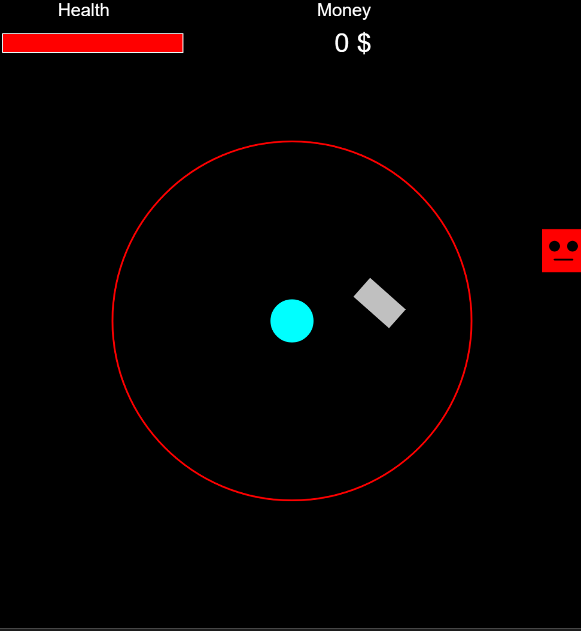

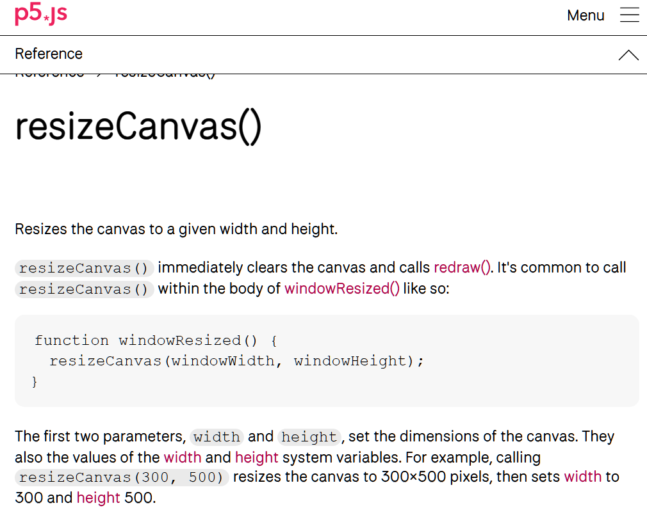
After some time of researching, it seems p5 has a way to resize objects on a canvas when screen size is changed – simply what I need in this situation.
So, to make this game “responsive” I would need a way to know when the user changes the screen size, to then re-adjust where everything is drawn onto the canvas – this should update every time the user changes screen size.
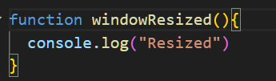
Firstly I wrote the function and added a quick test to see if resizing the screen actually works .

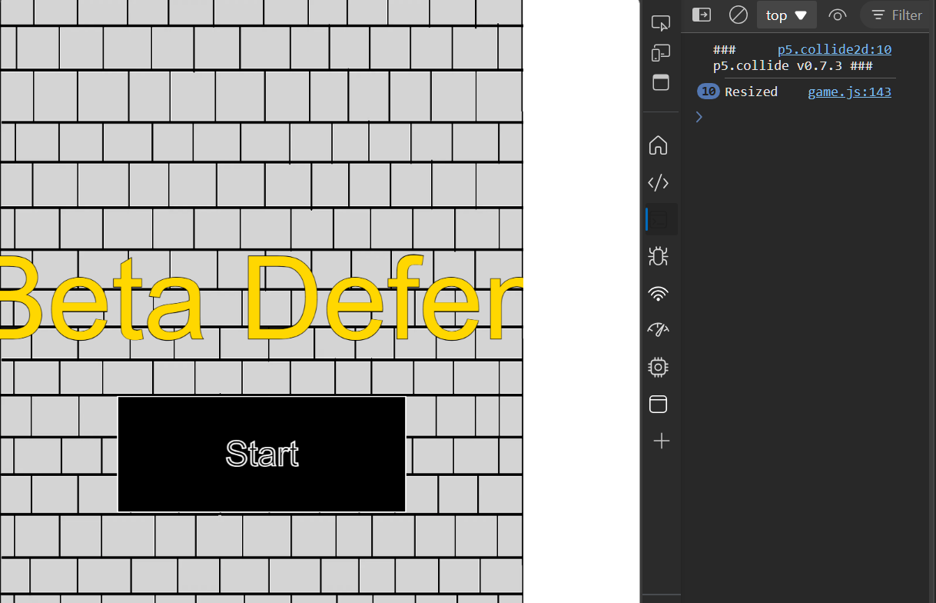
And so it did, and so the next step would be writing a function in this to update each object on the canvas whenever the screen is resized.

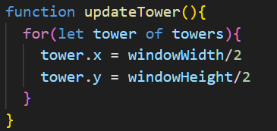

Starting with the tower, for each tower object – update the towers position each time the windowReized() function is called to a new position based on the current screen’s width and height.
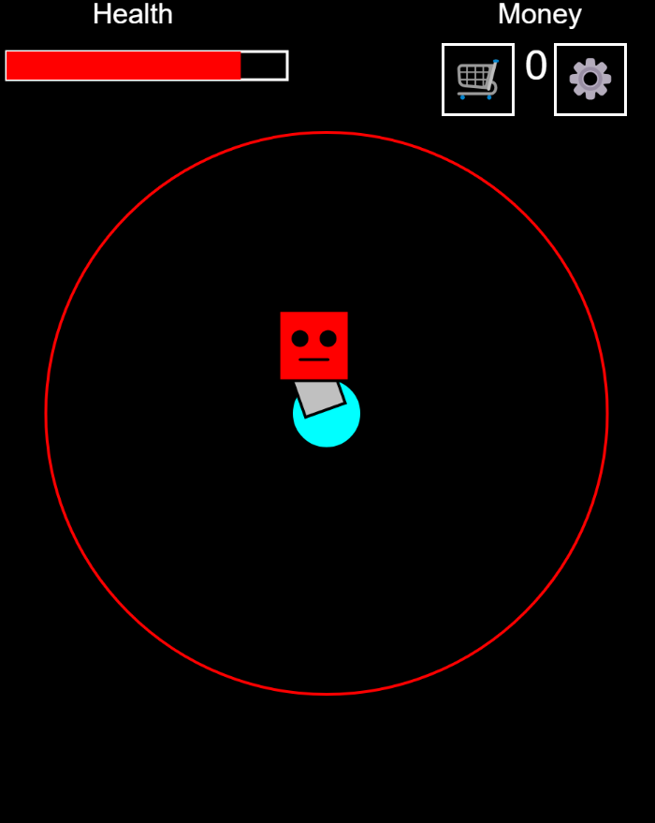
Nice, this seemed to have worked well, now I would just have to implement this for every single object ….
But of course things aren’t as easy as it seems, the next object I worked on adjusting was the tower range, problem was, the range wasn’t adjusting for some reason?
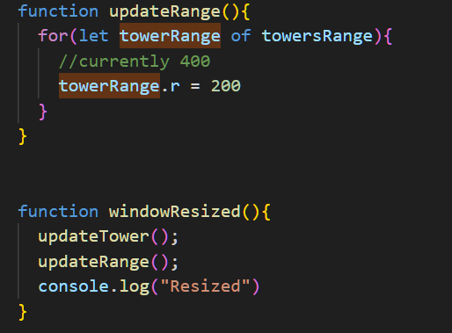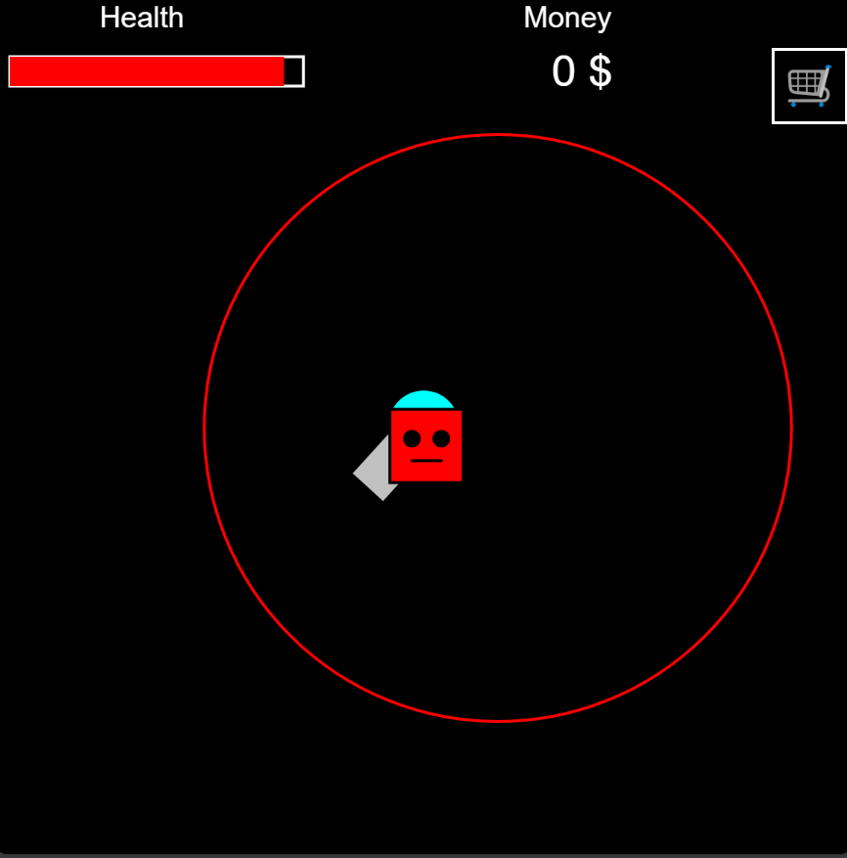
Well that didn’t work. So I looked at how my tower was drawn and noticed:
The tower wasn’t drawn with the radius property, so I added this in.
This didn’t change the resizing though, therefore it had to be within the tower property itself.
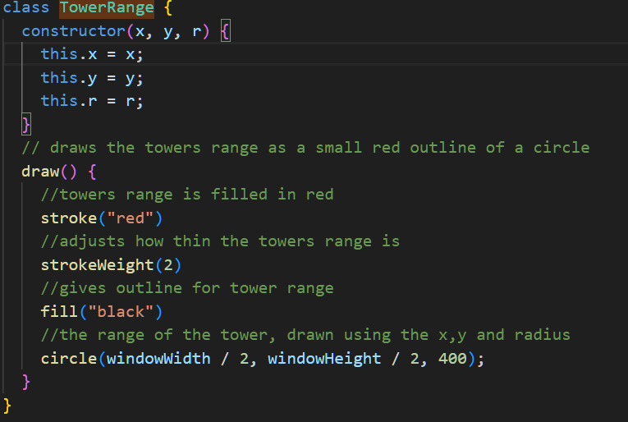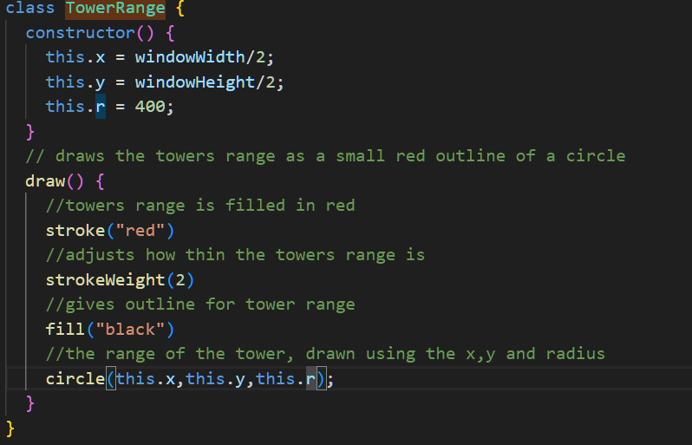
Due to my previous inexperience in programming I didn’t know how constructors worked, so it seems this is where the issue was : the constructor has parsed in values – currently x , y , r which didn’t really seemed to be used, I looked over at the structure of my tower code and how it worked, realizing that I had to set the values in order for them to be updated later, so I changed this code from left to right – old code to newer code.
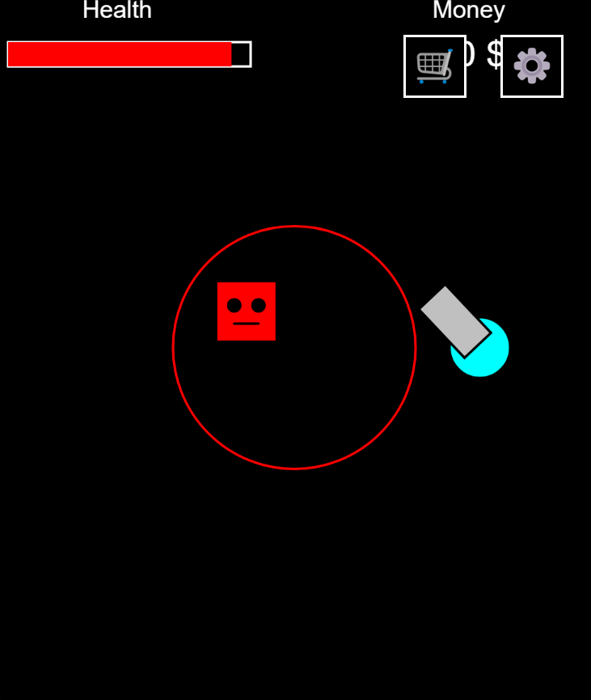
The range now successfully is resized, but shouldn’t this be connected to the tower? The range should also scale down based on the window size, so ill try make that happen.
I noticed since the tower and towers range (though should be part of the same object but past programmer me decided to make them separate) I could shorten my code by using the coordinates of the tower itself – hopefully this doesn’t break anything but I can revert this later.

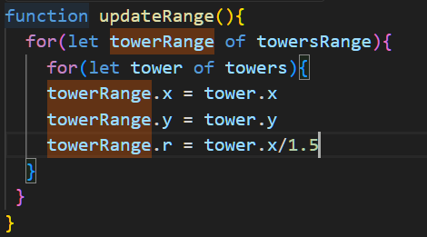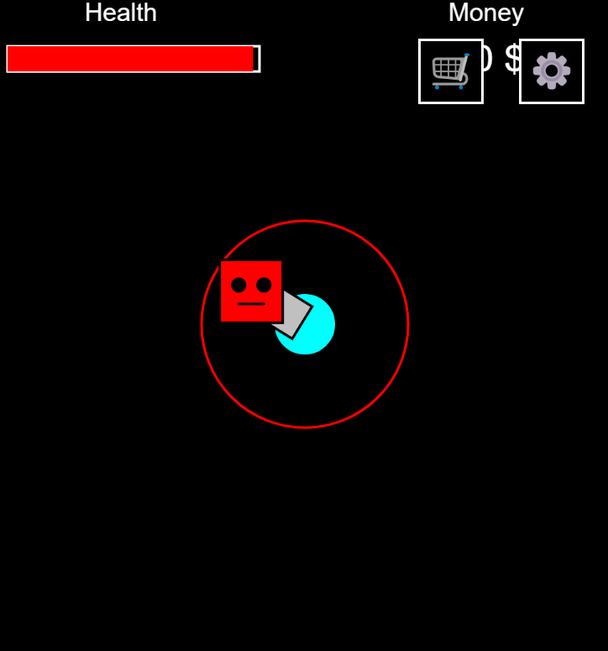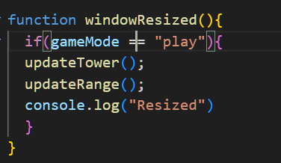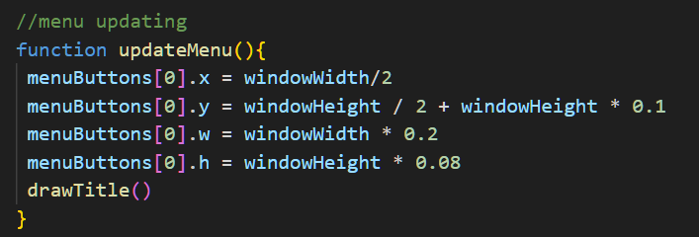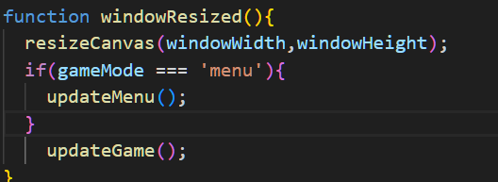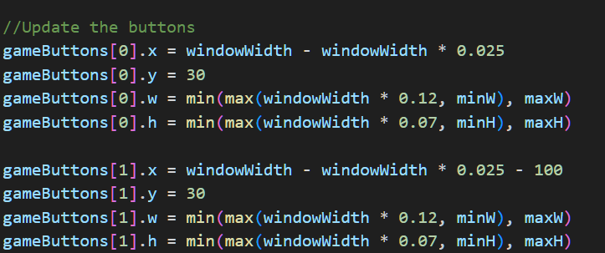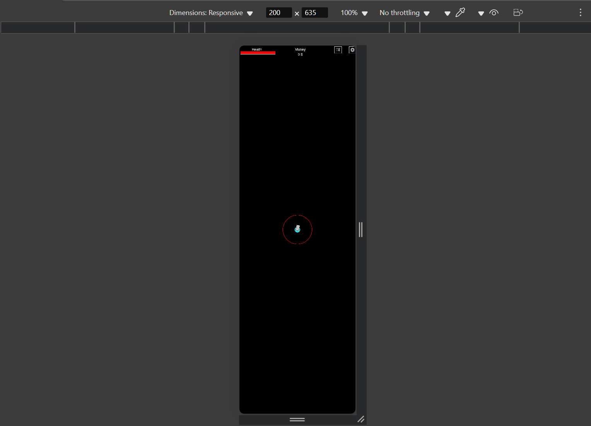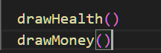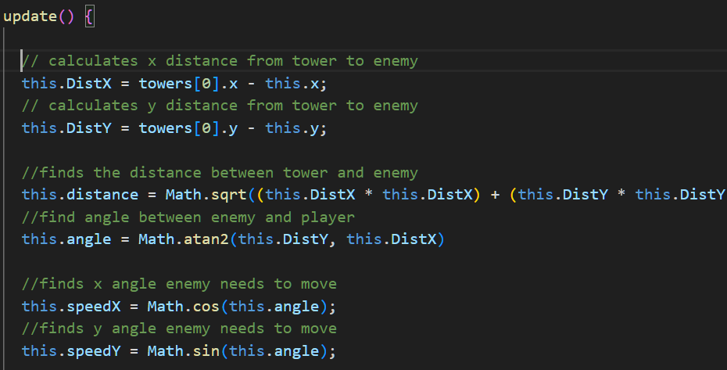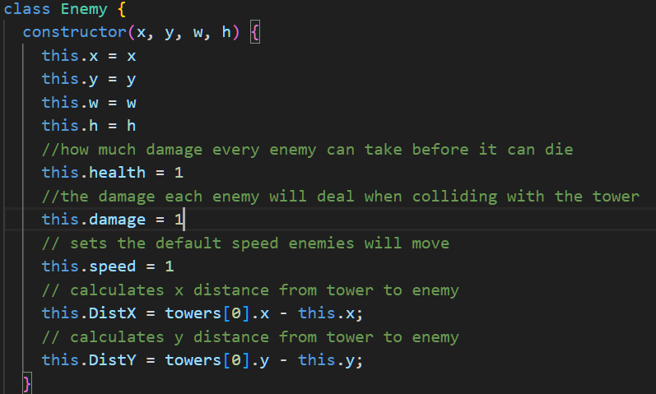
I updated the code to set the position to wherever the tower currently is on the canvas – perhaps I could add some further code later to this tower range update function when I start working on the upgrades section of the game.

Whilst I don’t really expect memory issues playing the game, the code does run unnecessarily whenever the screen is resized so let’s update the game only for when those object are needed to be resized based on the current game state the player is in.

Since this fixed most of the issues when resizing the screen, I basically have to now do the same for everything I have currently created since – the enemies need to relocate the tower once the screen changes as well as the other shop buttons UI I have made also require updating per screen size change.

So now that works let’s work on reformatting the other aspects of the game.

To fix the rendering of the menu objects similarly to the tower I would just have to reassign the buttons based on the window width and height and etc. Draw title could also be recalled to redraw the title with the new current window screen size. By multiply the window width or height by the decimal I could make sure the buttons appear at a certain point of the screen regardless of the screen size, I also applied this to the title for similar results.
Interestingly this does have a scenario when this doesn’t work – if the user changes the screen size before playing the game then plays the game the screen size doesn’t resize – only when the user resizes the screen again will it then be fixed, this is due to the logic on the left, therefore updateGame() should probably called always when the screen size is changed.
Similarly in the methods in game such as the buttons, text, health bar and etc, will use window width and height for screen scaling, I also used min and max since using window width and height can make the buttons end up being too small or large this will limit how large the display will be on the screen. Then using the inbuild developer tools I could test different screen sizes to see if this worked properly – to which it did after some refining.
Then, recalling previous draw methods are used to redraw the health and money to scale on the screen
When updating enemies I didn’t realise my calculations to make the enemy move towards the tower wasn’t within the update function therefore when update was called this just did not correctly path the enemies based on screen size change so I had to move this to update so the updated tower position can be used for enemies to move.
Here is a short demonstrating of this working:
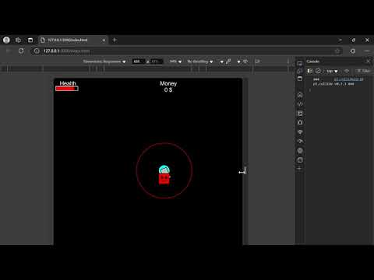

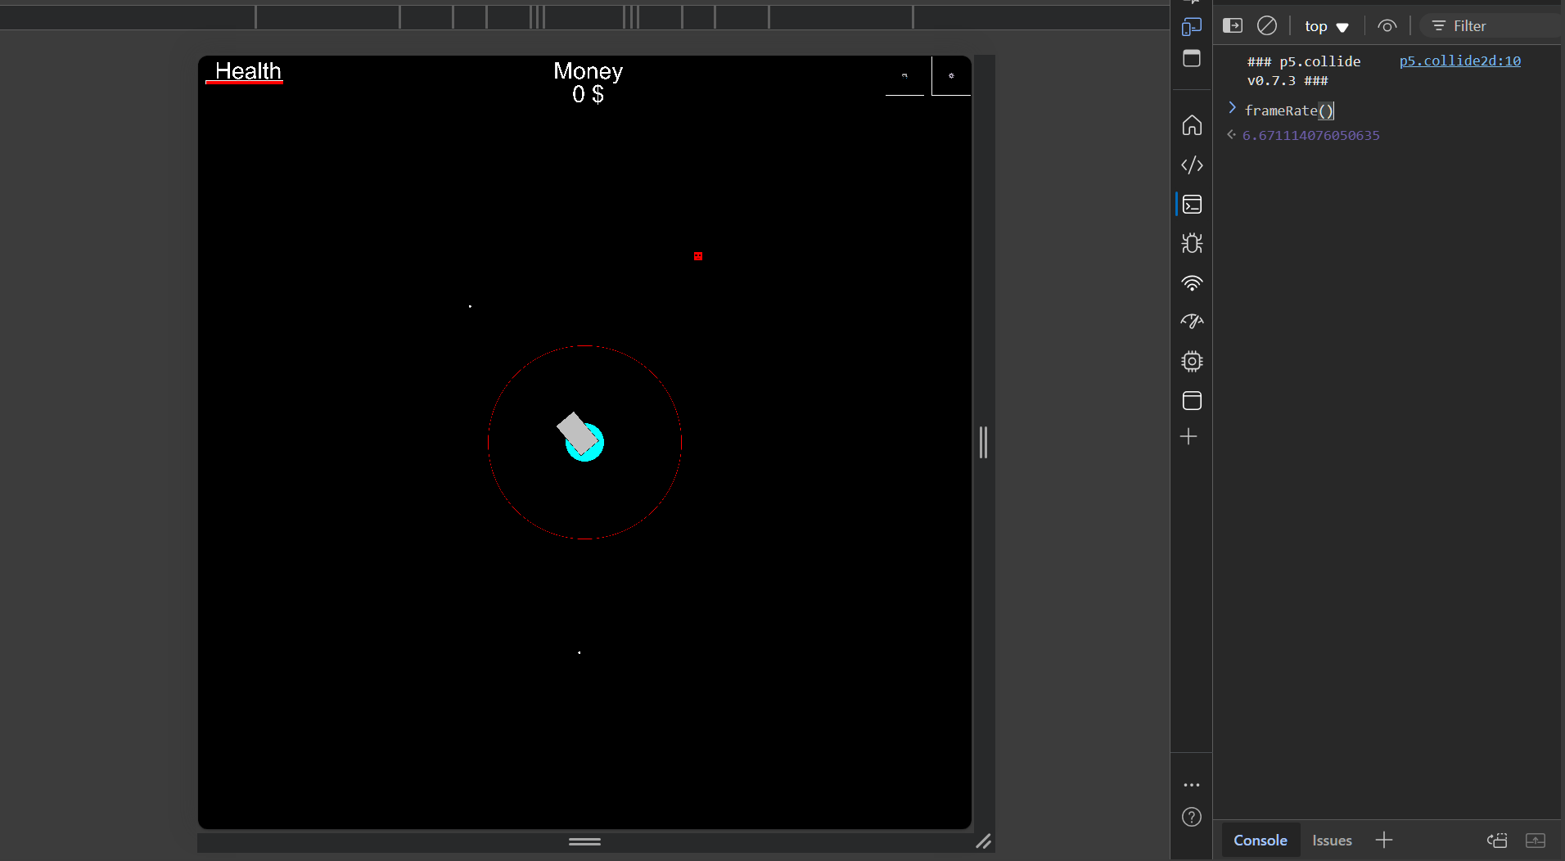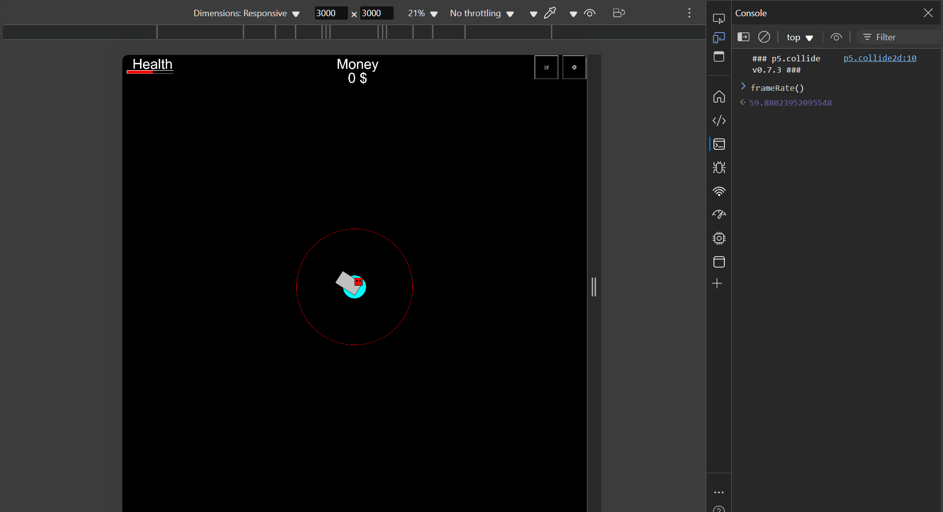
After some testing on different screen sizes, the game buttons modification previously didn’t seem quite right – as screen size increased, buttons could render beyond the screen making them of course not visible or they would overlap, instead, I iteratively went through a list of dimension to see what would look right and also be responsive to any screen.
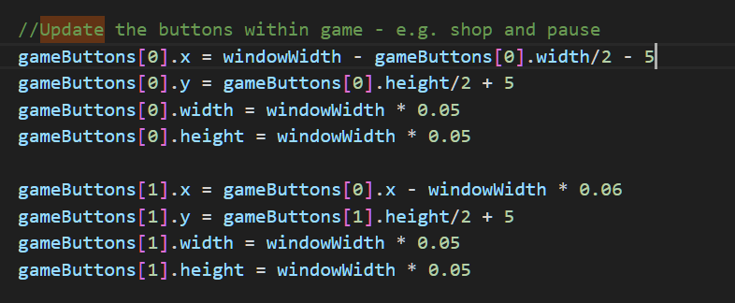
Instead if I adjusted the positioning of the buttons based on the width and height of the buttons then subtract or add it by the screen width and height I can ensure the buttons will always be within the current screen regardless of how large or small it is. For the cog button I wanted to position top right of the screen so achieve this I got the width of the button – the current screen width then a small offset so the button can be seen, similarly this was done with the shop button but the offset being the first button.
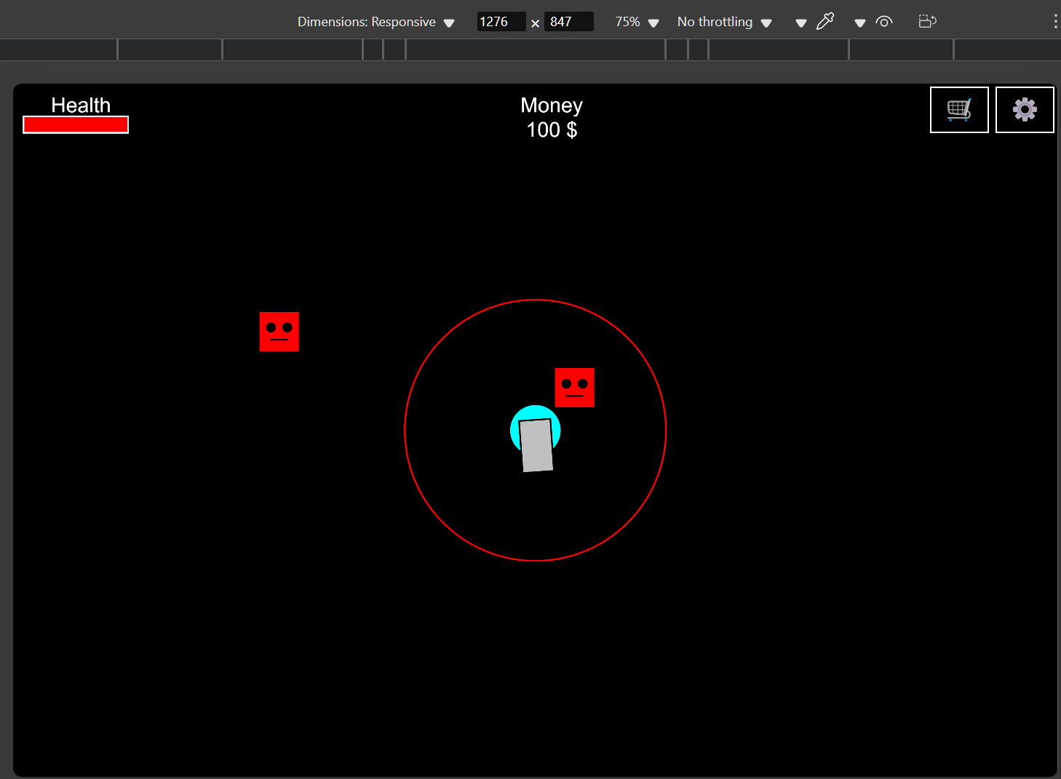
There seemed to be no issues this method allowing the game to be responsive regardless of screen size.

Performance Issues:
Currently, the game move atrociously slowly on larger screens but works perfectly fine on smaller screens, this is to be expected of course since the more pixels there are, the more pixels that need to be rendered within the canvas. There are actually a few ways I can deal with this. Most commonly found in games I’ve played is by limiting the resolution of the game by a certain resolution, or by using p5’s creates graphics which makes use of some sort of buffer to increase performance.
Since most of the code I use usually only uses a single for loop It should have a rough time complexity of O(n) meaning it should only start being severely impacted once there are many game objects on screen – enemies/bullets but since my bullets already get removed once they are off screen this shouldn’t really be a problem.

As seen within the picture in a screen size of 3000 x 3000 and using p5’s framerate() function which returns the current frame rate, the performance is pretty horrible especially on larger screens.
One easy method I looked into was p5’s pixelDensity() function which is basically a way to make pixels appear more clearly on screen, if I lowered this, perhaps it could lead to some performance increase?
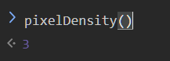
Currently pixel density is set to 3 so if I lower it, most likely this could lead to a smoother games – with the caveat of the game looking slightly worse, but I could implement a button later to allow the user to adjust this resolution.
This actually does significantly increase the current frames displayed per second since less pixels are “packed into an area” meaning less amount to resources required to render all of these pixels, therefore leading to this increase in frames. Now the frame rate increases from 6 -> 60 a significant increase.
But if the user would want to increase the game resolution this causes the frames to drop – as expected therefore another method on top of this will need to be added to make sure this is accounted for as well.
First there actually is some optimisations I can do.
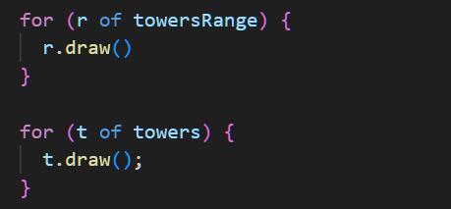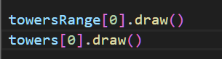
Since there is only one tower and range for that tower, there is no need to loop through the array, we can just look at the first tower in the array.
Secondly in methods such as draw some backgrounds are being redrawn every second which is not required an example of this is in menu, whilst the menu is drawn correctly, it is also drawn multiple times per second which is not required since there is no need to update the menu as it is static.
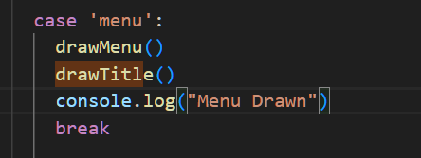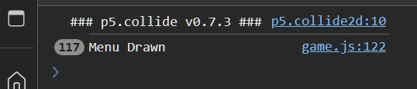
This is due to the methods being in draw which calls every so frames, and since the condition is perhaps always menu in that instance then it will continue this case infinitely until the case is changed, instead the case should only happen once and then the buttons will then make sure the case is appropriately changed when pressed. So a fix of this would be to just change the case so the condition can’t happen infinitely – I did this by changing the game mode to nothing once that game mode was drawn once.
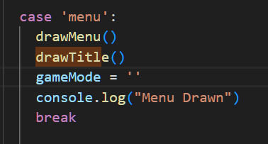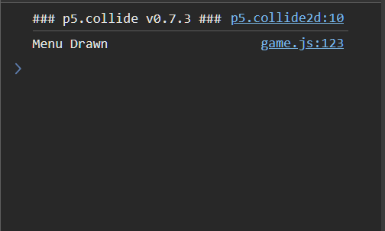
Similarly I applied this for all the other cases, not just then menu given that the background does not require any updating since redrawing is only required when object needed to move on screen – to be updated.

The fade in screen affect from the previous version of Beta Defence was broken due to this, so instead of relying on the background drawing multiple time to create this animation
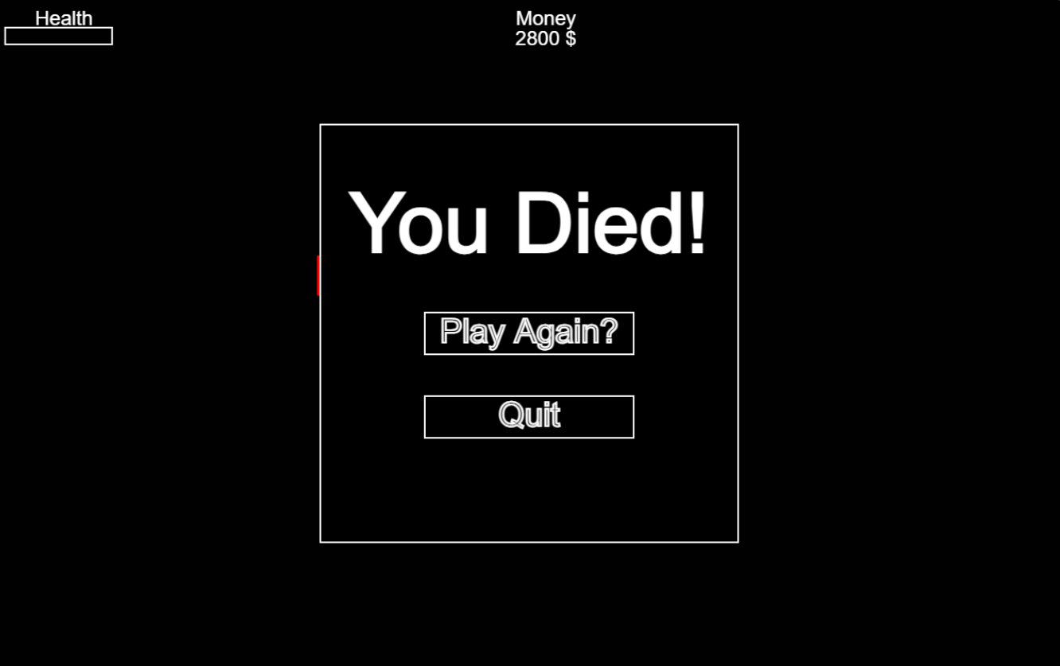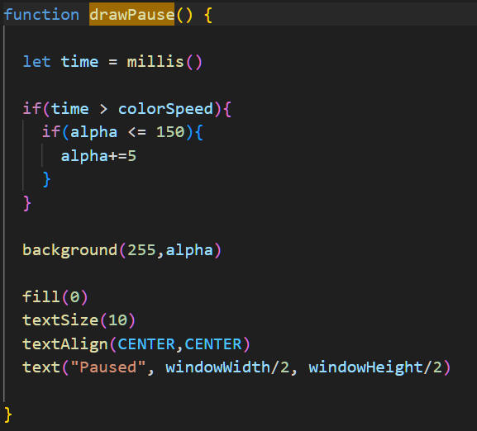
I created a function that increased the transparency of the background per second using p5s timing method of millis() then of course resetting this value once the user is not in this screen to make sure tis animation reset every time this current screen appears. This also involved having to redesign the pause can death screen to make sure it was scalable to different screens.
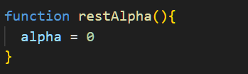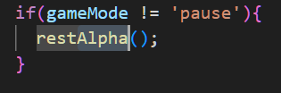
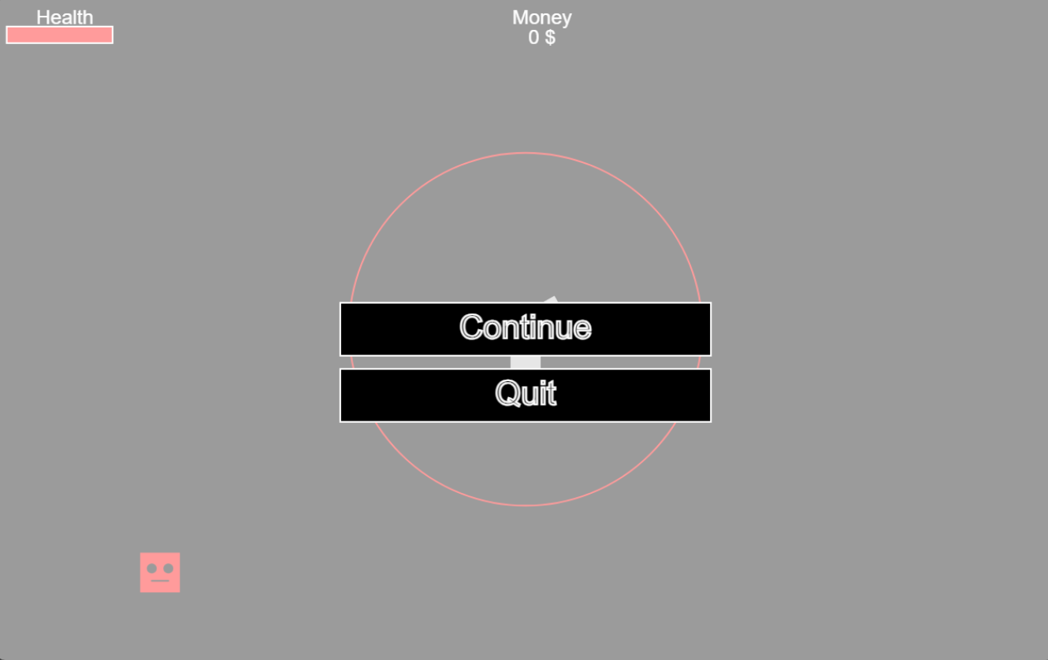

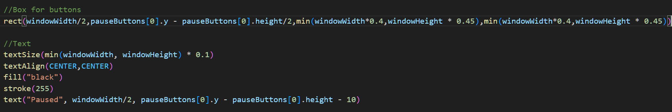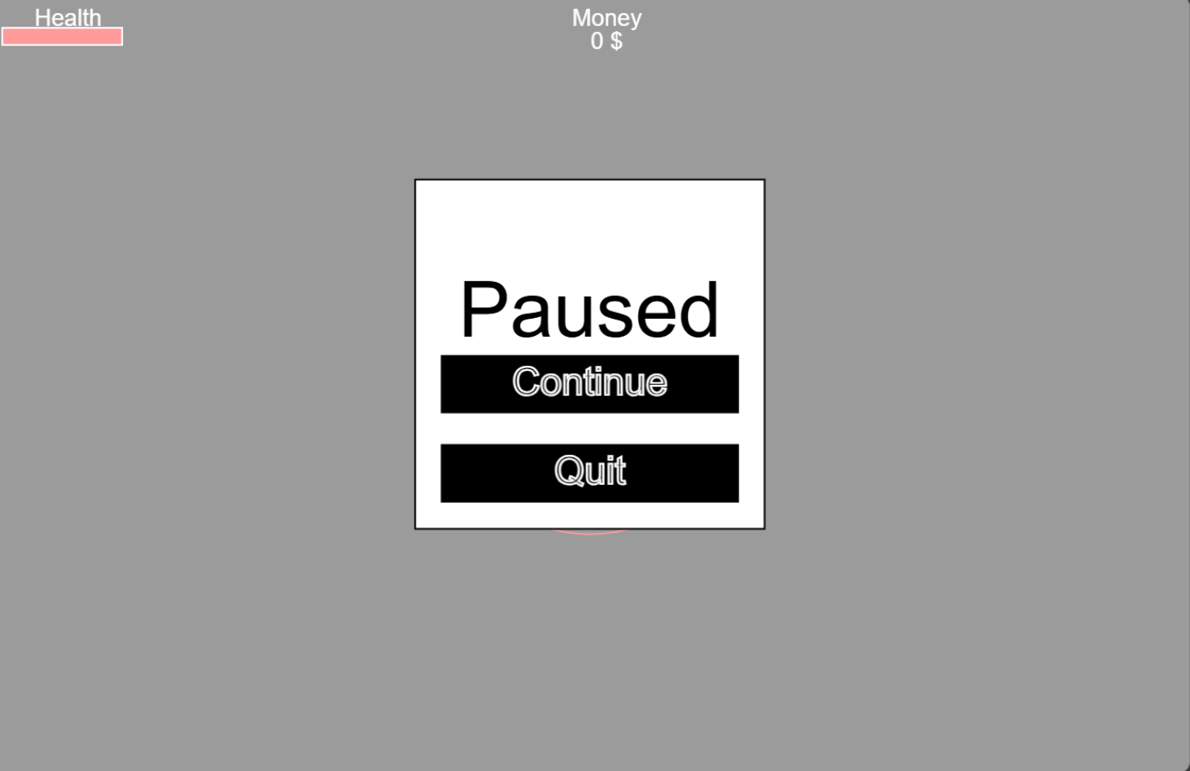
While testing the game on different screen sizes, I found the user could double tap on the screen, which would then zoom into the game making it rather difficult to play – so simply I just removed the ability to do that using the html viewport.

Screen Reformatting

Now to clean up the UI for the pause screen per screen size, to make sure each button like continue or quit display close to each other, I came up with the method to make use the coordinates of a previous button on screen (given that they are close to each other) this made sure that the button will always be positioned close to each other

Here to make sure the “Paused” text was always on top of the continue button I just used the coordinates of the continue button – basically the button height – so the text will appear at least one button away from continue and the added an offset so the text isn’t too close to the button.
Similarly I added the same kind of logic for the box to contain everything in the pause – using min to make sure the box also scales up and down with the screen width and height. This modification was also applied to the death screen.

Maximise button
Most of the game was now responsive, at least the current game object within the game. I thoroughly tested different screen sizes and most seemed to work perfectly when the screen size was changed. This is except one condition, if the user were to use the maximise/expand button (top right of any tab in a browser) window Resized event would not be triggered for some reason – this is only because this only triggers when the screen size is manually changed and some logic when you use the maximize button doesn’t fulfil this condition e.g. :
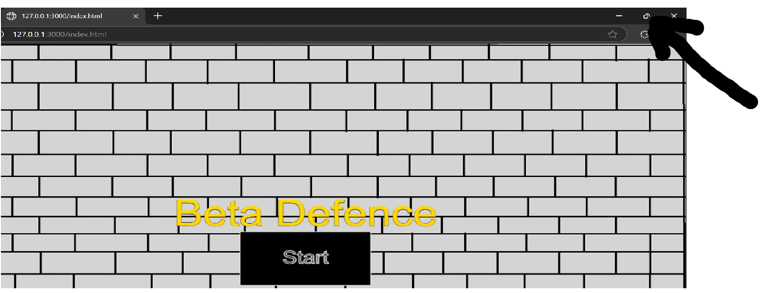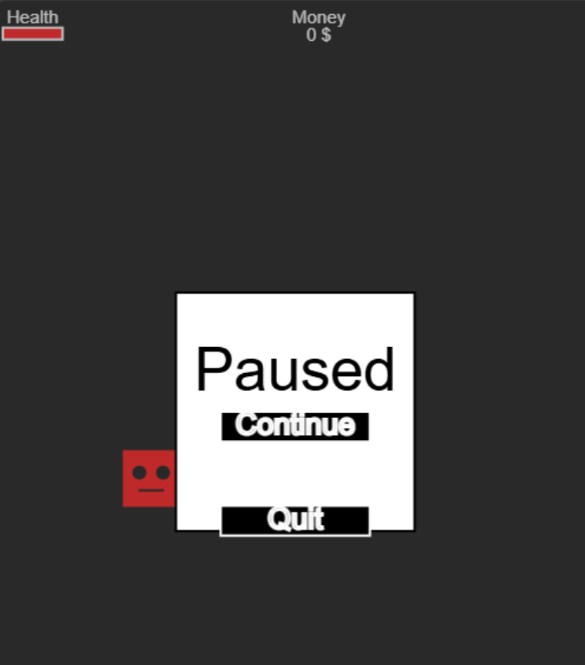

So some other method would need to be used to check if the current screen size has changed, if so then call the window Resized function to reformat the canvas.
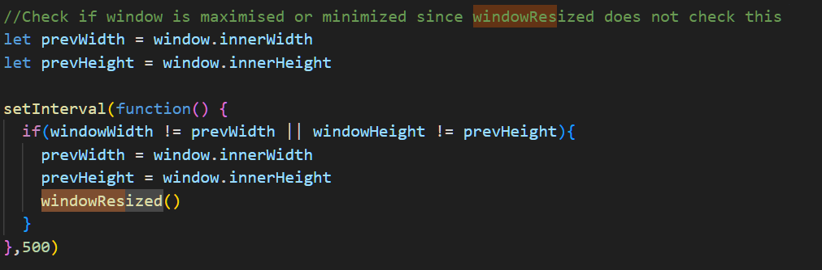
To do this I created some new variables to store the current width and height. An inbuilt method called setInterval can run a function x num of seconds, here I created a function and set it to check and update the game every ½ a second.
In terms of how the logic works : if the window size has changed via the width or height by comparing the current window to the previous window dimensions then the window has changed size and so, windowResized can be called to reformat all the elements on the page
The screen now reformats the elements in the game correctly when the screen size is changed or maximized.
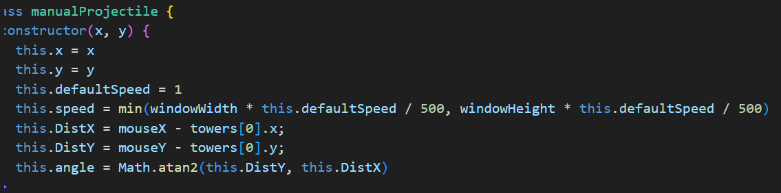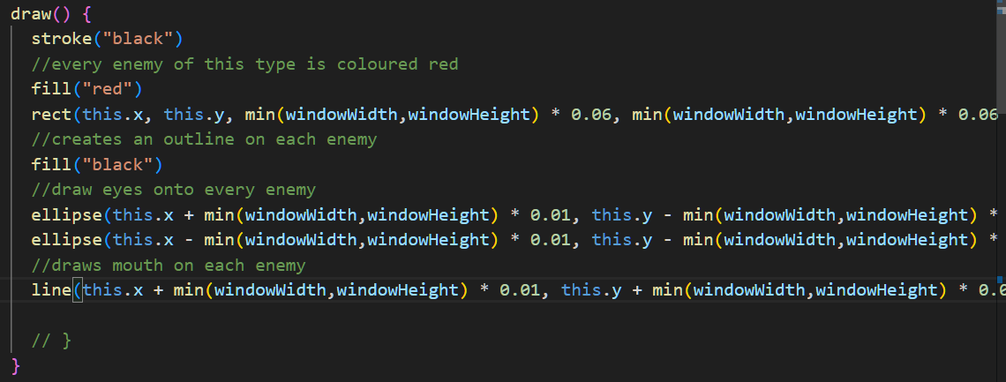

Updating the game
Now the game needs to work based on the screen size. Currently enemies move 1 pixel per frame, whilst this is fine on smaller screens this logic does not apply for the larger ones since there will be more pixels to traverse, this making the enemies and bullets seem very slow since they do not move at the screens size.
To update this, I changed the speed of the projectiles and the enemies to move roughly 0.02% of the current screen width or height whichever is smaller, this makes sure that the speed of these elements are consistent per different screen, in the equation I added default speed so I can modify this later with upgrades and divide that by a set amount to covert this speed to a set % of the screen.
Since there were no issues with this next objective was to scale the enemies and projectiles to the screen size, I would have to do what I did similarly with the menus and such using min() for scaling purposes here.

This was slightly more work to do since I had previously had my enemies at fixed sizes since I didn’t account to different screen sizes in the beta development, this was solved though by using the previous code and modifying it using min() to determine and scale the enemy looks based on the screen size
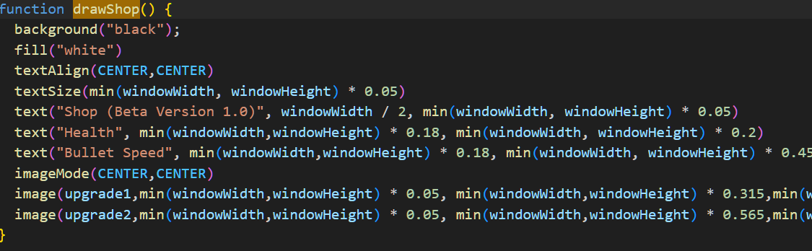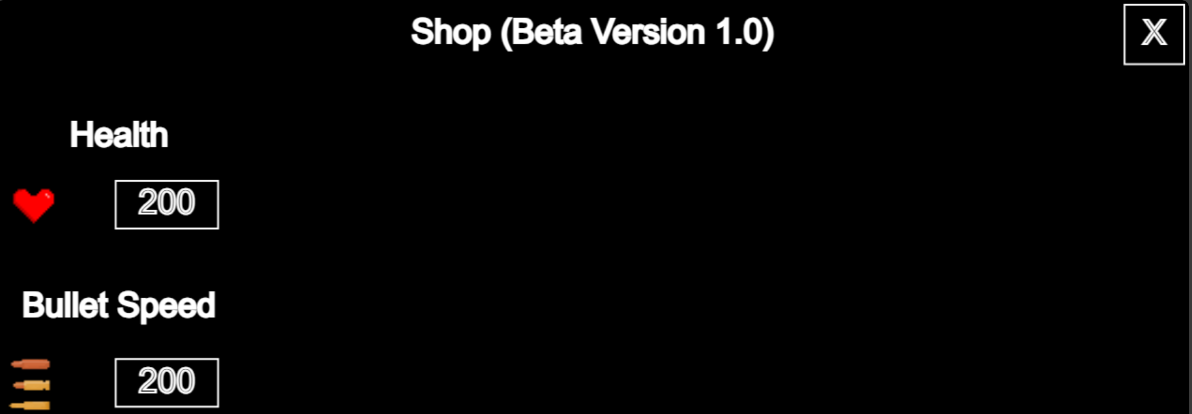
Shop Upgrades
Since the UI scaling is pretty much done, I will now focus on the game . First I will fix the positioning of the buttons and improve how it looks my adding some images.
First I import the images via preload and store them within a variable for later where I can draw them using the Image() function.
I added some free use images created by (xxashuraxx, 2025) and (sufan02, 2025) since I think they look nicer than what I could draw. I then repositioned the buttons using once again the min() function for each button. I plan to change the background and the buttons later in a graphics update but for now I will focus on finishing making the upgrades work first.

Then I created the images and scale them using the same rescaling methods, I made sure to distance the text and images roughly the same height and width away from each other to make sure the icons don’t look misplaced on different screen sizes.
Now to actually make the buttons work based on the upgrade itself – I will start on the health boost upgrade. So when this button is pressed there will be some checks – if the user has enough money, increase the user’s health and then increase the price of this upgrade – perhaps I could add some visual elements to make this easier to see later but of course this will be covered in a graphics update.

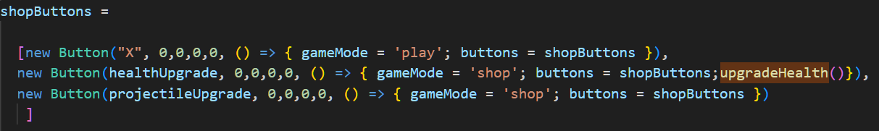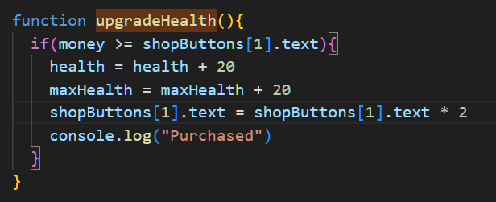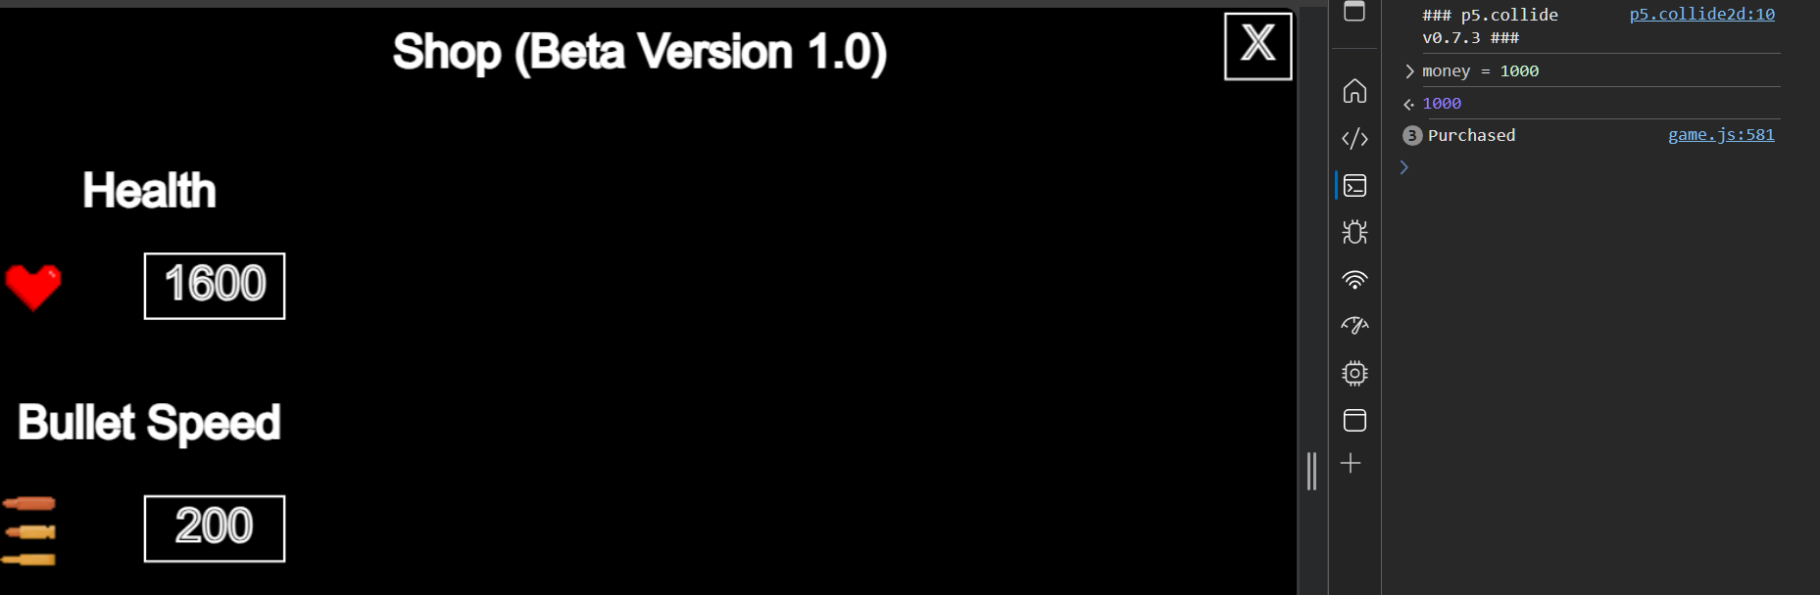
First in the shop buttons starting with the health upgrade, when the button is pressed, runs a lambda function which then will run some function that will increase the health.
For the function itself its simple checking – check if current money is greater or equal to the upgrade amount, if it is then increasing the health by some amount and then increase the money of that upgrade, note I use the .text value so when the shop is redrawn the value is updated .
After using the console to ethically give myself some money to test, the health text does increase correctly (given the user actually has the funds to do this of course). But what happens when the value gets pretty large? Will it fit in that box anymore?
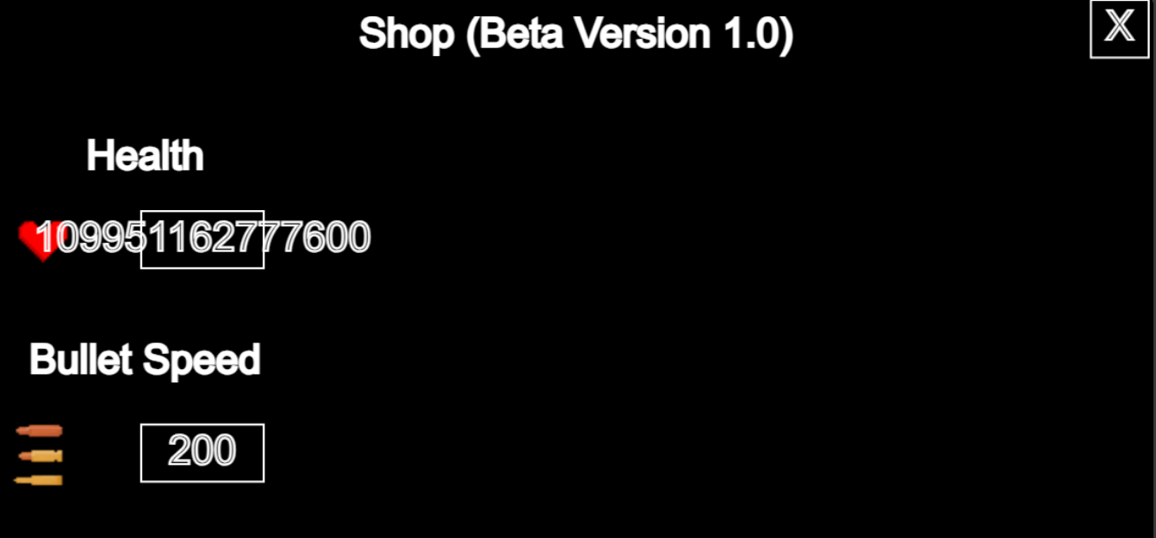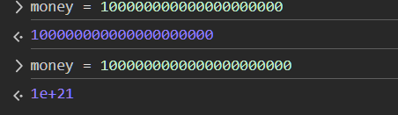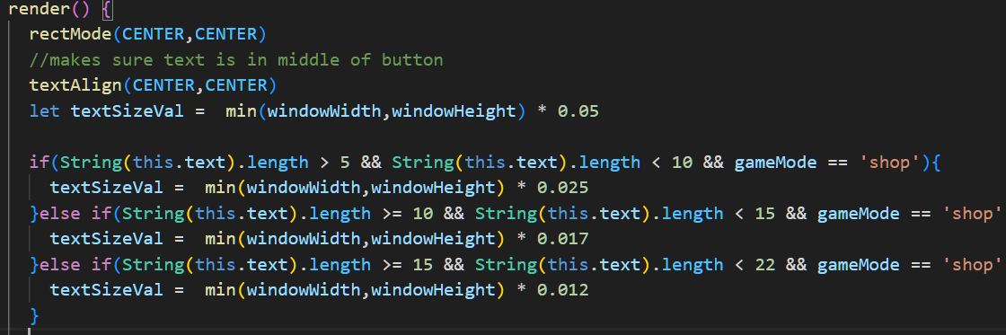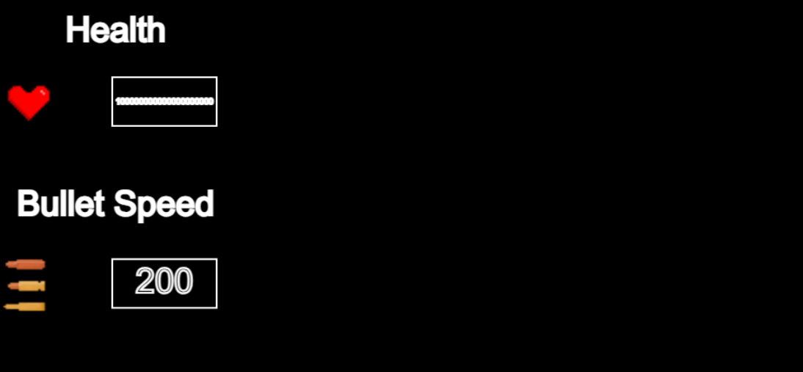
Not quite, the box can hold around up to a 5-digit number, after that, the content stops fitting in the box. My logic here to fix this would be to change the text size length when the value of the upgrade goes beyond what can fit in the button box, in this case it would be 5.
One method I tested in console was the limits of how far the money value could go, which determined after a length of 22 the int converted into Euler’s number which is the e constant which makes the money text length back to small again.
This took a few if else statements to adjust the text size based on the text length, but whilst when it did reach Euler’s number it looked fine before that the text eventually became extremely hard to see as seen within the picture below demonstrating this:
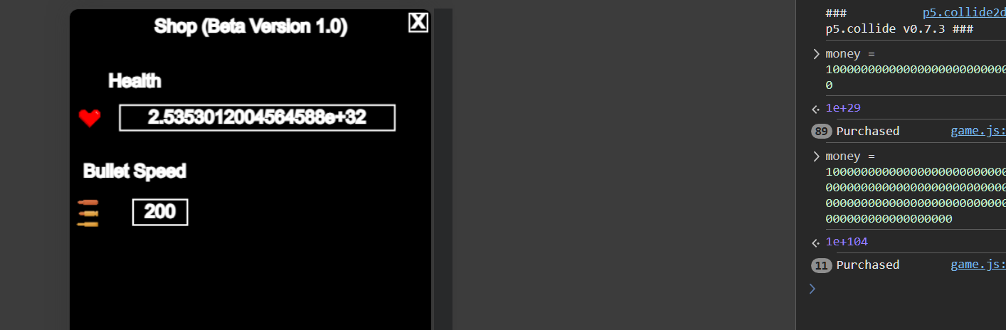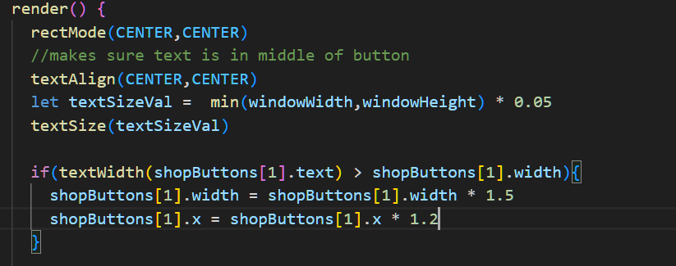
I used another p5 method, textWidth which in the name, measures and returns the width of the text, so if I compare that to the current button width : If the current text within the button is larger than the button itself, then increase the shop button width size and also increase the x coordinate so it doesn’t end up overlaying the heart icon.
I would say this method does work well and generally does scale up to some pretty high numbers before it will go off the screen from some randomly infinite number, but balancing how far the upgrades increase should fix that before that actually becomes an issue – this will be in a game balancing section in the future.

Make sure enemies can only start spawning as long as player is in game
